Experiment - 6
Online cake ordering system
Aim
To develop an Online Cake Ordering System that allows users to search cakes by category, flavor, and price, add cakes to a cart, place orders, and track delivery status. The admin can manage cake details, images, prices, orders, and shipping information.
Procedure
- Create a webpage using HTML for the cake ordering system.
- Add student registration and login options.
- Display cakes with images, descriptions, categories, and prices.
- Provide cake search and filtering options.
- Allow users to add cakes to the cart and place orders.
- Collect customer details and shipping addresses.
- Provide an order history and delivery status page.
- Create an admin section to manage products and update order status.
- Test the website to check its basic functions.

Sample Code
<!DOCTYPE html>
<html>
<head>
<title>Online Cake Ordering</title>
</head>
<body>
<h1>Sweet Cake Shop</h1>
<p>Order your favorite cakes online!</p>

<h2>Student Login / Register</h2>
<input placeholder="Username">
<input type="password" placeholder="Password">
<button>Login</button>
<button>Register</button>

<h2>Search Cakes</h2>
<input id="search" placeholder="Search cake">
<button onclick="searchCake()">Search</button>

<h2>Available Cakes</h2>
<p>Chocolate Cake - ₹500</p>
<button onclick="addCart('Chocolate Cake', 500)">Add to Cart</button>

<p>Vanilla Cake - ₹400</p>
<button onclick="addCart('Vanilla Cake', 400)">Add to Cart</button>

<p>Strawberry Cake - ₹600</p>
<button onclick="addCart('Strawberry Cake', 600)">Add to Cart</button>

<p id="result"></p>

<h2>My Cart</h2>
<p id="cart"></p>
<input id="address" placeholder="Delivery Address">
<button onclick="placeOrder()">Place Order</button>

<h2>My Order</h2>
<p id="order"></p>

<h2>Admin Panel</h2>
<p>Manage cakes, prices, products and delivery status.</p>

<script>
let total = 0;
let items = [];

function searchCake() {
let cake = document.getElementById("search").value;
document.getElementById("result").textContent =
"Search for: " + cake;
}

function addCart(name, price) {
items.push(name);
total += price;

document.getElementById("cart").textContent =
items.join(", ") + " | Total: ₹" + total;
}

function placeOrder() {
let address = document.getElementById("address").value;

if (items.length === 0 || !address) {
alert("Add a cake and enter your address.");
return;
}

document.getElementById("order").textContent =
"Order placed! Items: " + items.join(", ") +
" | Total: ₹" + total +
" | Delivery: " + address;

items = [];
total = 0;
document.getElementById("cart").textContent = "";
}
</script>
</body>
</html>

Output

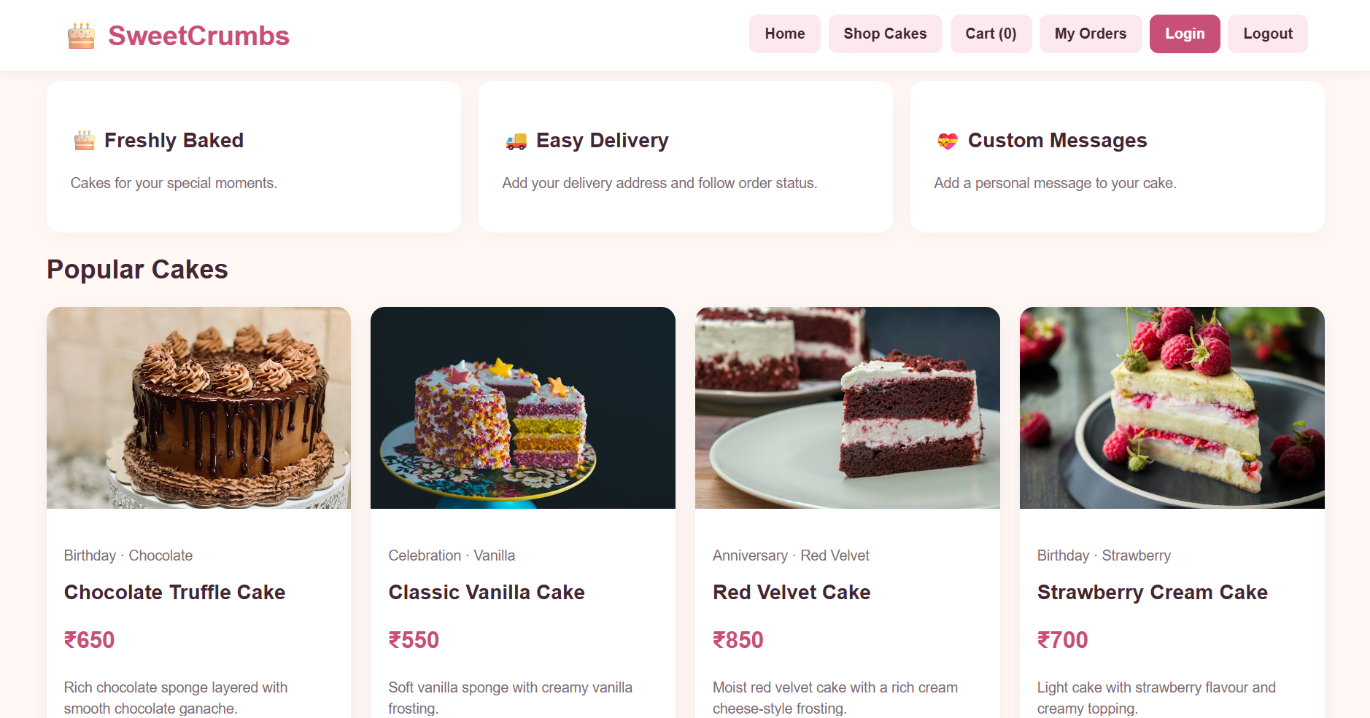

Result
The Online Cake Ordering System webpage was created successfully. Users can search cakes, add products to their cart, enter a delivery address, and place a sample order. The admin section represents product and order management. Real login, payments, image uploads, inventory, and delivery tracking require a backend and database.

